Canny Carz

project management plan

Version *1.0*

*01/30/2020*

VERSION HISTORY

|  |  |  |  |  |  |
| --- | --- | --- | --- | --- | --- |
| **Version #** | **Implemented**  **By** | **Revision**  **Date** | **Approved**  **By** | **Approval**  **Date** | **Reason** |
| 1.0 | Vineeth Thaduri and Sai Vishal Rudra | *01/30/2020* | *Kamaljeet* | *01/30/2020* | *For learning about Managing Project in IT Industry* |

TABLE OF CONTENTS

1. **Introduction 4**
   1. Purpose of Project Management Plan 4
2. **Executive Summary of Project Charter 4**
   1. Assumptions/Constraints 4
3. **Scope Management 5**
   1. Work Breakdown Structure 5
4. Product Analysis 5
5. Product Design 5
6. Product Development 5
7. Product Testing 5
8. Product Deployment 5
9. Product Maintenance 5
10. Host server 5
    1. Deployment Plan 5
    2. Change Control Management 5
11. **Schedule/Time Management 5**
    1. Milestones 5
    2. Project Schedule 6
12. **Cost/Budget Management 6**
13. **Quality Management 6**
14. **Human Resource Management 7**
15. **Communications Management 7**
    1. Communication Matrix 7
16. **Risk Management 7**
    1. Risk Log 7
17. **Issue Management 7**
    1. Issue Log 7
18. **Procurement Management 7**
19. **Compliance Related Planning 7**

**Appendix A: Project Management Plan Approval 9**

**APPENDIX B: REFERENCES 10**

**APPENDIX C: Screenshots: 11**

**Flow chart: 12**

**APPENDIX D: SUMMARY OF SPENDING 14**

# Introduction

## Purpose of Project Management Plan

The purpose of canny carz is there are multiple but separate platform for booking rides and car rentals, so we decide to combine all these platforms in one single application and also include some other services like drive school training for getting G2 and G license.

# Executive Summary of Project Charter

* “Canny Carz” is an Android or IOS based application platform for the riders and drivers to book a ride or rent a car.
* It provide platform for subscriber to buy or sell their new and used car.
* To develop reliable system that can facilitate admin and guest login separately.
* To develop user friendly application platform.

## Assumptions/Constraints

*Assumptions:*

* The budget of the project is $100,000
* The project is completed within the schedule.
* All the physical resource will be available whole the time.

*Constraints:*

* The project will be completed in 30 days.
* Only one resource is working on it.
* Less expertise of resource in coding.
* Should meet the deadline.

# Scope Management

* To develop user login.
* Ride booking
* To develop driver’s login.
* Ride car
* To develop buy and sell cars.
* To develop car rentals.

## Work Breakdown Structure

## Product Analysis

## Product Design

## Product Development

## Product Testing

## Product Deployment

## Product Maintenance

## Host server

## Deployment Plan

* The deployment should be after the Testing of all the deliverable.
* Deployment will take 8 day.

## Change Control Management

* Change Control Board incorporated to decide whether the change will be entertained or not.
* CCB include another stakeholder or the project manager only

# Schedule/Time Management

* Product must be completed in 30 days
* All the deliverable must be achieved during the timeframe

## Milestones

The table below lists the milestones for this project, along with their estimated completion timeframe.

|  |  |
| --- | --- |
| **Milestones** | **Estimated Completion Timeframe** |
| Design Complete | 06 day |
| Development complete | 12 days |
| Testing complete | 10 days |
| Deployment | 8 days |

## Project Schedule

# Cost/Budget Management

* *The project budget is $100,000.*
* The project cost is $85, 000.
* Project Management cost is 20000
* $5,00 risk reserve
* $1000 project management reserve.
* $5,000 marketing cost.
* $500 contingency cost.

# Quality Management

Quality Assurance: From the starting of the project till the deployment.

Quality Control: From the starting of the project till the Testing.

# Human Resource Management

Only one human resource is working on this project

# Communications Management

Communicate project with the project sponsor by:

* Weekend meeting
* Project status report meeting.

## Communication Matrix

|  |  |  |  |  |  |
| --- | --- | --- | --- | --- | --- |
| **Stakeholder** | **Messages** | **Vehicles** | **Frequency** | **Communicators** | **Feedback Mechanisms** |
| Vineeth Thaduri | *Project requirement* | *Email* | *High* | *Push* | *Constructive* |
| *Sai Vishal Rudra* | *Project requirement* | *Email* | *High* | *Push* | *Constructive* |
| *Kamaljeet* | *Project report* | *Email* | *High* | *Push* | *Critical* |

# Risk Management

The uncertainties involved in project development.

**RISK**

Risk management is the identification, evaluation, and prioritization of risks followed by coordinated and economical application of resources to minimize, monitor, and control the probability or impact of unfortunate events or to maximize the realization of opportunities.

**IDENTIFYING RISKS**

Full project team should be actively involved.

Potential risks should be identified by all members of the project team.

No criticism of any suggestion is permitted.

Any potential risk identified by anyone should be recorded, regardless of whether other members

of the group consider it to be significant.

All potential risks identified by brainstorming should be documented and followed up by the

|  |  |
| --- | --- |
| project schedule risk factors | buffer time may help to over come this |
| technical errors | analyst can cover and solve |
| Quality | improving quality of application |
| risk in budget | maintaining contingency reserve |
| conflicts among team members | stress free environment |

IPT.

**RECOVERING RISKS**

## Risk Log

* Xcode crash.
* Miss code submission deadline.
* Syntax error.
* WiFi crash

# Issue Management

***Concern that are involving during the execution of the project***

## Issue Log

* Xcode is not upto date.
* Data cable not working.
* Resources are not available like sick calls.
* Emulator not working.

# Procurement Management

* Database procurement
* Server allocation.

# Compliance Related Planning

**Appendix A: Project Management Plan Approval**

The undersigned acknowledge they have reviewed the *Sinkart* **Project Management Plan** and agree with the approach it presents. Changes to this **Project Management Plan** will be coordinated with and approved by the undersigned or their designated representatives.

|  |  |  |  |
| --- | --- | --- | --- |
| Signature: |  | Date: |  |
| Print Name: | Vineeth Thaduri |  |  |
| Title: | Developer |  |  |
| Role: | Project manager |  |  |

|  |  |  |  |
| --- | --- | --- | --- |
| Signature: |  | Date: |  |
| Print Name: | Sai Vishal Rudra |  |  |
| Title: | Developer |  |  |
| Role: | Project manager |  |  |

|  |  |  |  |
| --- | --- | --- | --- |
| Signature: |  | Date: |  |
| Print Name: | Kamaljeet |  |  |
| Title: | Instructor |  |  |
| Role: | Project Sponsor |  |  |

**APPENDIX B: REFERENCES**

The following table summarizes the documents referenced in this document.

|  |  |  |
| --- | --- | --- |
| **Document Name and Version** | **Description** | **Location** |
| *Project Management Plan(Version 1.0)* | *Consist of project scope, schedule, risk, quality and resource management plan* | *Canadore College* |

**APPENDIX C: Screenshots:**

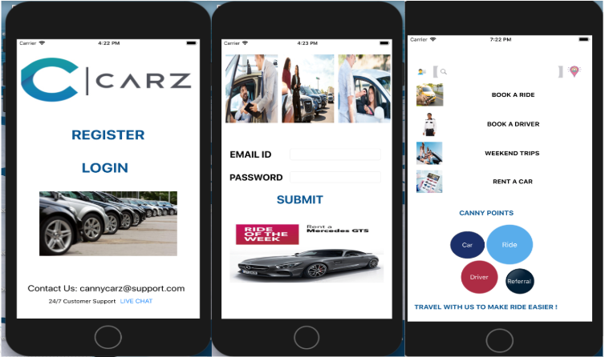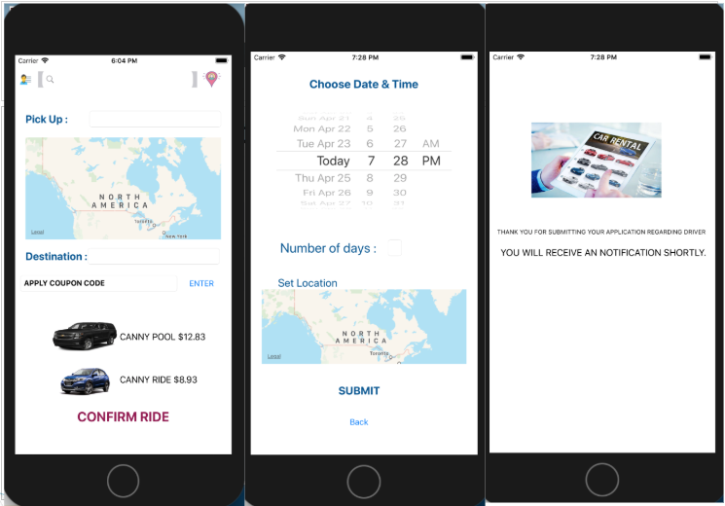

**Flow chart:**

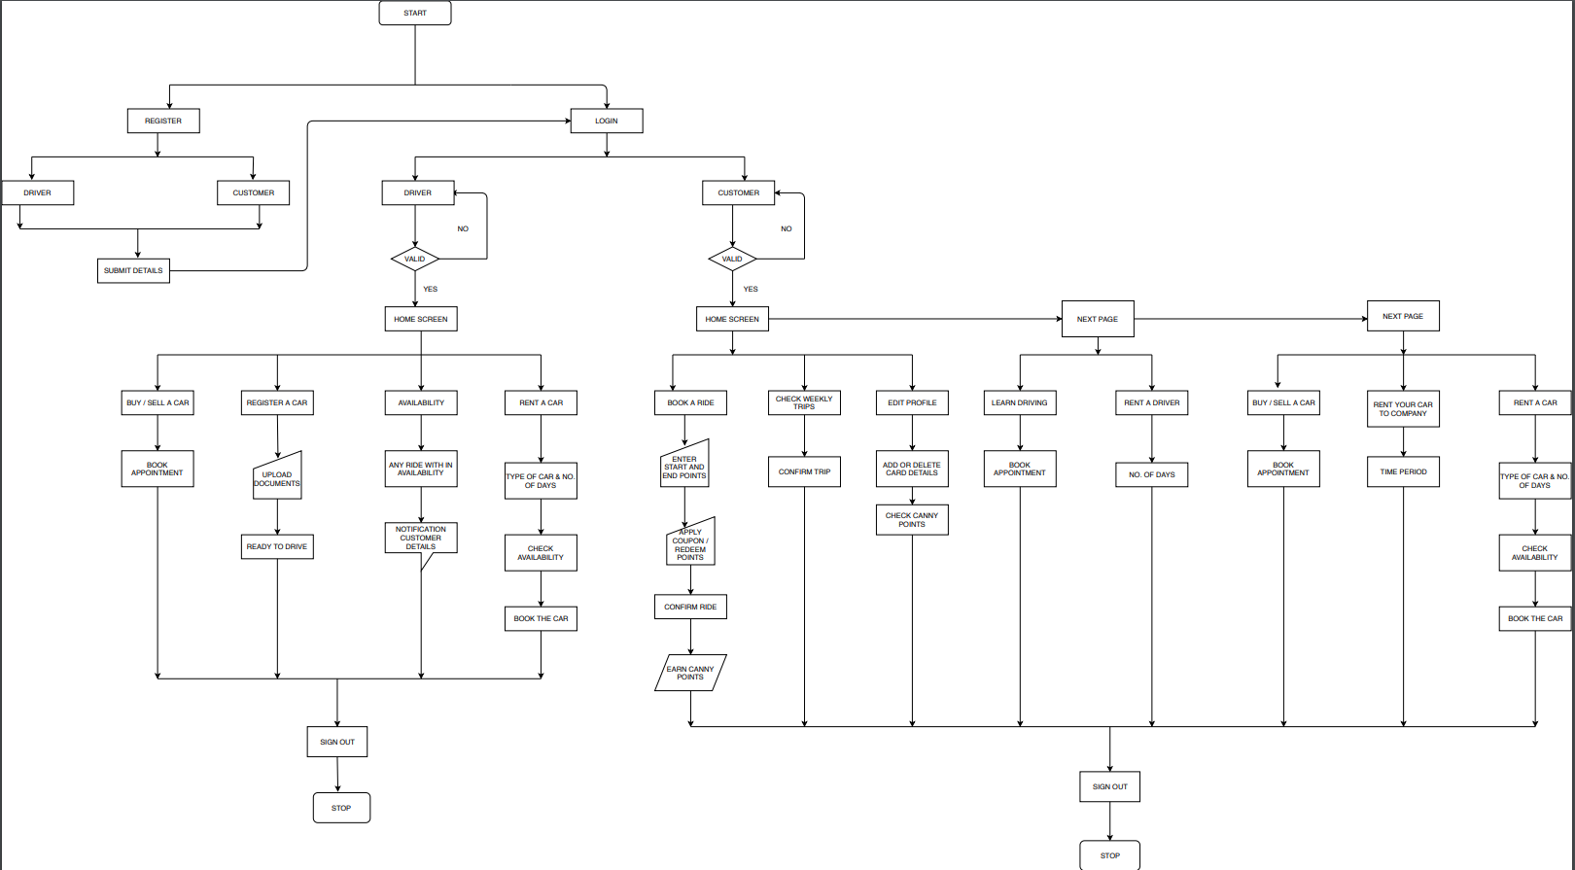

**APPENDIX D: SUMMARY OF SPENDING**

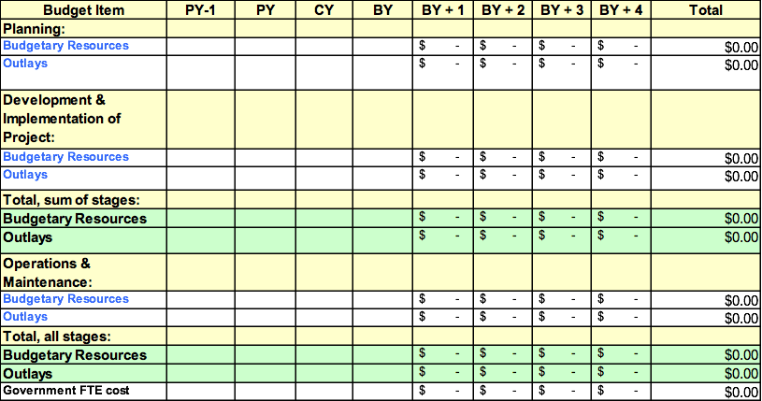PY: Previous Year; CY: Current Year; BY: Budget Year